Riphah International University Lahore, Pakistan

Riphah School of Computing & Innovation

Final Year Project

PROJECT REPORT

AI-Powered Speech Dysfluency & Stuttering Detection

Project Team

Student Name | Student ID | Program | Contact  Number | Email Address
Name | 0000 | BSCS | O3O00000000 | email@
Name | 0000 | BSCS | 03000000000 | email@

Chapter 1
Introduction

Introduction
Speech dysfluencies, particularly stuttering, are communication disorders that disrupt the normal flow of speech and can include blocks, prolongations, repetitions of sounds or words, and interjections, affecting millions of people worldwide, significantly impacting their communication, confidence, and quality of life. Stuttering is commonly observed in children, though it can persist into adulthood if not addressed early. Traditional speech therapy is effective but often expensive, time-consuming, and inaccessible to many individuals. Moreover, existing digital tools provide limited support and lack real-time detection or personalized feedback. Despite advances in technology, current digital tools remain limited in addressing these challenges, highlighting the need for innovative approaches to support individuals with speech dysfluencies.

1.1. Background
Stuttering and speech dysfluency are communication disorders that interrupt the natural flow of speech through blocks, repetitions, and sound prolongations. These conditions affect both children and adults, impacting social confidence, academic performance, and mental well-being. Traditional speech therapy requires trained professionals, regular sessions, and is often expensive, making continuous support difficult for many individuals. Recent advancements in artificial intelligence and speech processing offer opportunities to automate speech analysis and assist therapy. Therefore, there is a growing need for intelligent systems that can detect stuttering early, analyze speech fluency, and support therapy through personalized guidance.

1.2. Motivations and Challenges
The primary motivation behind this project is to provide accessible, affordable, and technology-enhanced speech therapy support. Many individuals do not receive timely treatment due to cost, limited therapists, and social stigma. Existing apps lack real-time stutter detection, detailed progress tracking, and adaptive exercises. Challenges include processing noisy audio, identifying multiple types of stutters accurately, and ensuring the system works for different users. Building a real-time AI speech model that performs reliably on real-world speech data presents a technical challenge that this project aims to address.

1.3. Goals and Objectives
The goal of this project is to build an AI-based system capable of detecting stuttering patterns and guiding users toward improved speech fluency. Key objectives include:
- Detect different dysfluency types such as blocks, repetitions, and prolongations
- Provide real-time fluency score and instant feedback
- Highlight stuttered words and events in transcripts
- Suggest personalized speech exercises for improvement
- Track user progress through graphical reports

1.4. Existing Solutions
Feature | Eloquent | Stamurai | Stutter Stars | VoiceIt | Linguist | FluEntra
Stuttering Detection | NIL | NIL | Limited (game feedback) | NIL | NIL | AI detection of stutter types: blocks, prolongations, sound/word repetitions, interjections
Fluency Scoring | NIL | Basic stats | Reports | NIL | NIL | Precise 0–100 fluency score per session, updated dynamically with real-time analysis
Therapy Exercises | Fluency shaping, CBT | Fluency shaping, DAF, breathing | Speech drills  in-game | Pronunciatio n focus | Fluency + pronuncia tion | Custom exercises tailored to detected stutter types, with targeted training for each type
Progress Tracking | Dashboard s, mood | Statistics,  assessme  nts | Graphs + reports | NIL | NIL | improvement graphs, stutter type trends
Feedback | NIL | NIL | In-game only | NIL | NIL | Live speech analysis + instant suggestions, highlighting exact stuttering events & offline (recorded)
Personalize d  Interventio n | NIL | NIL | NIL | NIL | NIL | Adaptive exercises based on AI-detected stuttering patterns, intensity, and frequency
Target Audience | Teens/Adul  ts | All ages | Kids  (mainly) | Adults (voice training) | Learners (fluency) | general-purpose speech therapy, for adults
Unique Edge / USP | Gamified CBT | Compreh  ensive therapy plan | Game-bas ed practice | Pronunciatio n only | Fluency &  pronuncia tion | AI-driven real-time stuttering detection, multilingual support, targeted exercises per stutter type, precise scoring, and personalized feedback
Model /  Algorithm Used | Rule-Based + NLP (CBT prompts) | Hidden  Markov  Model  (HMM) +  DAF | Convoluti onal Neural  Network  (CNN) |  | Recurrent  Neural  Network  (RNN /  LSTM) | Hybrid deep learning  (wav2vec2.0 + CNN + BiLSTM  + Attention)
MFCC +
Support
Vector
Machine
(SVM)
Purpose / Focus | Improves confidence and speech fluency through CBT guidance | Detects speech timing irregularit ies and delays | Detects disfluency sound events during games | Evaluates pronunciatio n and clarity | Models temporal  sequence  s for  language learning | Detects stutter type, fluency score, and provides personalized therapy

Literature Review
Literature Review on AI-Based Speech Therapy and Stuttering Detection
To explore recent progress and identify research gaps, I reviewed key studies on AI-driven speech therapy, stuttering detection, and hybrid deep learning models. These works apply wav2vec 2.0, CNN–LSTM, and transformer architectures to improve speech analysis, fluency detection. The table below summarizes major contributions and open-access links.
Title |  | Authors/Year | What they do / key idea | Link
Detecting Dysfluencies in Stuttering Therapy Using wav2vec 2.0  (Placeholder1) |  | Bayerl, Wagner,  Nöth,  Riedhammer  (2022) | Fine-tunes wav2vec 2.0 to detect types of stuttering (blocks, prolongations, repetitions etc.), across datasets. (ISCA Archive) | https://arxiv.org/abs/2204. 03417
Automatic Speech  Disfluency Detection  Using wav2vec2.0 |  | J. Liu et al. (2023) | Uses wav2vec 2.0 + new datasets to detect disfluencies in English & Chinese. Focuses on variable-length disfluent speech.  (MDPI) | https://www.mdpi.com/20 76-3417/13/13/7579
Self-supervised Speech  Models for Word-Level  Stuttered Speech  Detection |  | (2024) | Applies self-supervised models like WavLM, contrastive training, Siamese networks to get better detection of stutters at the “word level.” (arXiv) | https://arxiv.org/abs/2409. 10704
Evaluative comparison of machine learning algorithms for stuttering event detection |  | Ramitha et al.  (2024) | Compares different ML algorithms for detecting stuttering events, evaluating performance. (ScienceDirect) | https://pubmed.ncbi.nlm.ni h.gov/39650118/
A Stutter Seldom Comes  Alone — Cross-Corpus  Stuttering Detection as a  Multi-label Problem |  | Bayerl, Wagner,  Baumann, Hönig,  Bocklet, Nöth  (2023) | Looks at detecting multiple dysfluency types at once (multi-label) across different datasets (English, German).  (arXiv) | https://arxiv.org/abs/2305. 19255
AI-Based Automated  Speech Therapy Tools for persons with Speech Sound Disorders: A  Systematic Literature  Review |  | Deka, Shrivastava,  Abraham,  Nautiyal, Chauhan  (2022) | Review of tools that help with speech sound disorders (SSD). What works, what’s missing,  what’s been built. (arXiv) | https://arxiv.org/abs/2204. 10325
Speech Emotion  Recognition Using Hybrid  Deep Models |  | Sharma & Gupta  (2023) | Emotion detection in speech, supports adaptive therapy feedback | https://www.mdpi.com/20 76-3417/13/8/4750
Multilingual Recognition wav2vec 2.0 | Speech Using | Conneau et al.  (2021) | Demonstrates multilingual  capabilities of wav2vec2.0 | https://arxiv.org/abs/2006. 11477
Hybrid CNN–LSTM Model for Speech Disorder  Detection |  | Patel et al. (2022) | Combines CNN and LSTM to detect patterns in disordered speech | https://www.iaeng.org/IJA  M/issues_v53/issue_4/IJA  M_53_4_29.pdf
Real-Time Feedback in  Speech Therapy via AI |  | Kaur & Singh  (2023) | Real-time speech correction system using AI-based analysis | https://arxiv.org/pdf/2308.  08713.pdf
Deep Learning in  Stuttering Therapy |  | Mahmood et al.  (2021) | Uses deep learning to improve  fluency scoring in speech  disorders | https://arxiv.org/pdf/2107. 04057.pdf
AI for Personalized Speech Interventions |  | Noor et al. (2024) | Suggests adaptive therapy plans using speech recognition models | https://pmc.ncbi.nlm.nih.g ov/articles/PMC12524231/

1.5. Gap Analysis
Current digital solutions mainly focus on general speech improvement or static therapy exercises rather than real-time dysfluency detection. Most applications do not analyze specific stutter types, provide detailed reports, or adapt exercises based on speech patterns. Research models exist, but very few have been implemented as accessible therapy-support tools. This gap highlights the need for an integrated AI-powered system that performs accurate stutter detection, real-time scoring, and user-specific therapy recommendations.

1.6. Proposed Solution
The proposed solution, FluEntra, is an AI-powered software application that provides real-time stuttering analysis and intervention. Users can record their speech, which is processed by an AI model to detect and classify dysfluencies such as blocks, prolongations, and repetitions. The system delivers immediate visual feedback through highlighted transcripts, event tables, and a dynamic fluency score. Based on this analysis, FluEntra suggests personalized exercises tailored to the user’s frequent stutter patterns. A dedicated Therapist Mode offers detailed progress reports, enabling therapists to track clients remotely and support data-driven, accessible speech therapy.

1.7. Project Plan
The project will be developed in phases, including research, system design, model training, UI development, backend integration, testing, and deployment. Agile methodology will be followed with weekly sprints, task tracking, and milestone reviews. Team members will share responsibilities for documentation, development, machine learning, and testing, supported by faculty supervision and evaluation checkpoints.
1.7.1 Work Breakdown Structure (WBS)

Project Management
- Work Breakdown Structure (WBS) & Project Charter
- Roles & Responsibility Matrix
- Change Control & Version Management System
- Weekly Sprint Planning & Review Meetings

Reports / Documentation
- Final Documentation & Project Report
- Literature / Market Survey & Competitive Analysis
- Software Requirements Specification (SRS)
- System Design & Architecture Documentation
- Implementation & Coding Documentation
- Testing & Model Performance Evaluation Report
- Conclusion & Future Work
- End-User Manual (Patient/Therapist)
- Application Administration Guide
- System Deployment & API Documentation

Development Environment Setup
- IDE Setup (VS Code, PyCharm, Android Studio)
- Version Control Setup (Git/GitHub)
- Backend Server Environment (Django)
- Database System Setup (Firebase/MySQL)

Presentation Layer (Frontend – Flutter)
- User Authentication & Profile Management UI
- Voice Recording & Playback Interface
- Real-Time Results Dashboard (Fluency Score, Highlighted Transcript)
- Progress Tracking & Analytics Graphs UI
- Personalized Exercise Modules & Games UI
- Therapist Mode Portal UI

Business Logic Layer (Backend – Django)
- User Authentication & Authorization API
- Audio File Upload & Management API
- Integration API with AI Model Service
- Session & Progress Tracking Logic
- Exercise Recommendation Engine
- Report Generation & Data Analysis Logic

Data Management Layer
- User Profile & Authentication Database Schema
- Audio Session & Stutter Event Logs Schema
- Fluency Scores & Progress History Schema
- Exercise Library & User Assignment Schema
- Therapist-Client Relationship Mapping Schema

AI Model & Physical Layer
- Data Preprocessing & Spectrogram Feature Extraction Module
- Stutter Detection & Classification Model (e.g., wav2vec 2.0 fine-tuning)
- Fluency Score Calculation Algorithm
- Model Serving API (e.g., Flask/FastAPI)
- Background Noise Cancellation Module

1.7.2. Roles & Responsibility Matrix:

WBS # | Deliverable | Key Activities | Duration  (Days) | Responsible Member(s)  & Role(s)
1.0 | Project  Management | WBS & Charter, Roles Matrix,  Version Control, Sprint Planning | 5–60 | Both Members (Planning  & Agile), (System Admin)
2.0 | Reports/  Documentation | Literature Survey, SRS, Design  Docs, Coding Docs, Testing  Report, User & Admin Manuals,  Final Report | 5–15 | Member 1 (Researcher),  (Analyst/Writer),  (QA/ML), Member 2  (Architect/Admin), (Final  Report)
3.1 | Dev  Environment  Setup | IDE, GitHub, Backend Server,  Database Setup | 4 | Both Members  (Developers), Member 2  (Backend Lead)
3.2 | Frontend (UI) | Auth & Profile UI, Voice  Interface, Dashboard, Analytics,  Exercises, Therapist Portal | 10–18 | Member 2 (Frontend  Dev), Member 1  (Frontend Lead)
3.3 | Backend (APIs &  Logic) | Auth API, File Upload, AI  Integration, Progress Tracking,  Recommendation Engine,  Reports | 7–12 | Member 1 (Backend  Lead), Member 2  (Support)
3.4 | Data  Management | Database Schemas (User, Audio  Logs, Progress, Exercises,  Therapist Mapping) | 4–7 | Member 2 (Backend  Lead), Member 1 (ML  Support)
3.5 | AI & ML | Data Preprocessing, Stutter  Detection Model, Fluency  Scoring, Model Serving, Noise  Cancellation | 8–25 | Both Members (ML  Engineer)

1.7.3. Gantt Chart

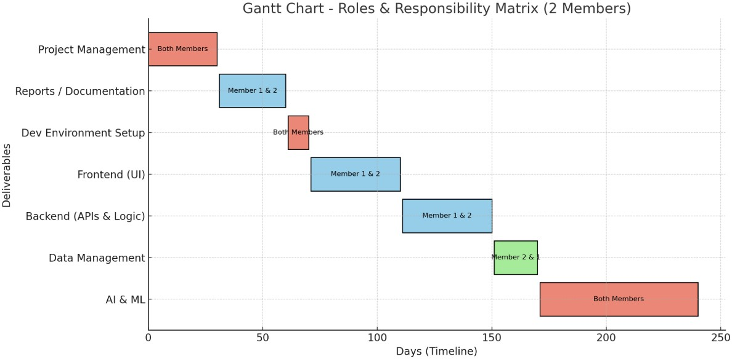

1.8 Report Outline
This report is structured into chapters covering introduction, literature review, system analysis and design, methodology, implementation details, results, evaluation, conclusion, and future enhancements. It includes diagrams, models, test results, and references to support academic standards and documentation requirements.

Chapter 2
Software Requirement
Specifications

2.1. Introduction
Speech dysfluencies, particularly stuttering, are communication disorders that disrupt the normal flow of speech and can include blocks, prolongations, repetitions of sounds or words, and interjections, affecting millions of people worldwide, significantly impacting their communication, confidence, and quality of life. Stuttering is commonly observed in children, though it can persist into adulthood if not addressed early. Traditional speech therapy is effective but often expensive, time-consuming, and inaccessible to many individuals. Moreover, existing digital tools provide limited support and lack real-time detection or personalized feedback. Despite advances in technology, current digital tools remain limited in addressing these challenges, highlighting the need for innovative approaches to support individuals with speech dysfluencies.

2.1.1. Purpose
FluEntra, is an AI-powered software application that provides real-time stuttering analysis and intervention. Users can record their speech, which is processed by an AI model to detect and classify dysfluencies such as blocks, prolongations, and repetitions. The system delivers immediate visual feedback through highlighted transcripts, event tables, and a dynamic fluency score. Based on this analysis, FluEntra suggests personalized exercises tailored to the user’s frequent stutter patterns. A dedicated Therapist Mode offers detailed progress reports, support data-driven, accessible speech therapy.

2.1.2 Document Conventions

Requirement Type | Label Format | Meaning | Example
Functional  Requirements | FR-Feature#-Req# | System  functions/features | FR-1-1
Non-Functional Requirements | NFR-Category-Req# | System quality rules | NFR-PERF-1

Priority Levels
Priority | Meaning
High (H) | Must have – required for core system and MVP
Medium (M) | Important but not required for first release
Low (L) | Optional enhancement for future versions

Feature Numbering – Fluentra
Feature No. | Module Name
1 | Real-Time Stutter Detection & Analysis
2 | Gamified Tongue-Twister Therapy
3 | Progress Tracking & Therapist Mode
4 | User Authentication & Profile Management
Examples
Requirement | Description | Priority
FR-1-1 | System allows users to start & stop voice recording | High
FR-2-1 | App provides tongue twisters in 3 difficulty levels | Medium
NFR-SEC-1 | User passwords must be hashed  (bcrypt) | High
NFR-PERF-1 | AI must process audio within 10 seconds | High

2.1.3. Intended Audience and Reading Suggestions
Project Managers & Supervisors: Should focus on Sections 2.1 (Introduction) and 2.2 (Overall Description) for scope and business context.
Developers & System Architects: Should read the entire document, with emphasis on Sections 2.3 (External Interfaces) and 2.4 (System Features) for technical specifications.
Testers & QA Team: Should use Section 2.4 (System Features) to derive test cases and verify all functional requirements.

2.1.4. Product Scope
FluEntra is designed for individuals with stuttering, as well as speech therapists. The application offers features such as real-time stutter detection, fluency scoring, stuttered word highlighting, detailed progress reports, personalized exercises, and noise cancellation for improved audio quality. It leverages machine learning and deep learning models to process audio input from a microphone in real time through a user-friendly interface. Initially, the system will focus on English speech using datasets like Libri_Stutter. While FluEntra provides valuable support, it requires an internet connection, does not fully replace therapists, and has limited customization for rare cases. The solution will be deployed as a web application with a free basic version and premium options. Its effectiveness will be evaluated through user testing, measuring accuracy, satisfaction, and improvements in pre- and post-fluency scores.

2.2. Overall Description

2.2.1. Product Perspective
FluEntra is a standalone AI-powered speech-therapy assistant designed to support individuals with stuttering. The system analyzes real-time voice input using machine-learning models to detect stutter patterns and provide instant feedback, progress tracking, and guided tongue-twister exercises. It includes a Flutter-based mobile app, cloud-based AI processing, and a secure backend for user data.The platform also offers a therapist view for monitoring user progress, making FluEntra a digital companion that complements traditional speech-therapy sessions.

2.2.2. Product Functions
The system will provide the following key functions:
- Real-time speech recording and stutter detection
- AI-based speech analysis and fluency scoring
- Instant corrective feedback for users during speaking exercises
- Gamified tongue-twister practice with multiple difficulty levels
- Progress tracking with historical performance graphs
- Personalized practice recommendations based on performance
- User account creation and secure login system
- Cloud-based storage for voice sessions and progress data
- Accessibility features to support speech-therapy users

2.2.3. User Classes and Characteristics
Primary Users
- Individuals with stuttering or fluency disorders
- Need an easy-to-use interface and guided speech practice
- Will use the system for daily speech exercises and feedback System Admin
- Manages user accounts, system settings, and data security
- Ensures proper functioning and access control

2.2.4 Operating Environment
- Frontend:
Web-based interface built using ReactJS, HTML, CSS, and JavaScript
Compatible with modern browsers (Chrome, Edge, Firefox, Safari) ● Machine Learning Backend:
Python-based stuttering detection model (e.g., PyTorch/TensorFlow)
Served through a REST API (Flask / FastAPI)
- Database:
Firebase or MongoDB / PostgreSQL (depending on system structure) ● Hosting/Deployment:
Cloud hosting such as Firebase Hosting, AWS, or Render / Vercel ● Networking:
Stable internet connection required for speech processing and progress sync ● DevicesSupported:
Desktop, Laptop, Tablet, and Mobile Browsers

2.2.5 Design and Implementation Constraints
- The AI speech model must be trained/fine-tuned using Python ML libraries (e.g., PyTorch / TensorFlow).
- Application frontend must be developed using ReactJS.
- Backend API must be implemented in Python (Flask / FastAPI).
- Real-time audio processing depends on web browser microphone access.
- The system must ensure secure handling of user data (HTTPS, encrypted storage).
- Limited browser microphone accuracy may affect stutter detection precision.
- Internet connection required for model inference (unless offline mode added in future).

2.2.6 User Documentation

Documentation Type | Description
User Guide | Digital & PDF guide for regular users explaining how to record voice, view results, and track progress

2.2.7 Assumptions & Dependencies

Category | Details
Assumptions | Users have a working microphone & stable internet connection
Dependencies | System performance depends on Python ML libraries (PyTorch/TensorFlow) and quality of stutter dataset

2.3 External Interface Requirements

2.3.1 User Interfaces
Interface | Description
Login Page | Email/password login

Dashboard | Start recording, view results
Speech Analysis Screen | Live/recorded speech input & detection feedback
Results Page | Transcript + highlighted stutters + fluency score
Progress Page | Graphs & history

2.3.2 Hardware Interfaces
Microphone(Laptop/Mobile :
Used to capture and record user speech for analysis by the AI model.

2.3.3 Software Interfaces
Interface | Technology |  | Purpose
Frontend → Backend | REST API (HTTPS) |  | Send user input, receive results
Backend → ML Model | Python FastAPI / Flask |  | Run stutter detection
Backend → Database | Firebase / MongoDB  PostgreSQL | / | Store user progress & login data

2.3.4 Communication Interfaces

Protocol | Purpose
HTTPS / TLS 1.2+ | Secure data transmission
JSON | Data exchange format

2.4 System Features

2.4.1. Voice Capture (Record & Upload)

2.4.1.1 Description and Priority
Provides web-based recording and file-upload of speech samples (live microphone recording and uploaded audio). Priority: High (core user input channel).

2.4.1.2 Stimulus/Response Sequences
- User clicks Record → system requests microphone permission → system shows recording timer → user clicks Stop → system uploads the audio and shows “Processing” status.
- User selects Upload → chooses audio file → system validates format and size → system uploads file and shows “Processing” status.
- User cancels recording → system discards temporary file and returns to dashboard.
2.4.1.3 Functional Requirements
- REQ-SF1-1: The system shall allow registered users to record audio via the web dashboard using the device microphone.
- REQ-SF1-2: The system shall request and handle browser microphone permissions securely and show appropriate user feedback if permission is denied.
- REQ-SF1-3: The system shall allow users to upload audio files up to a configurable maximum size (TBD).
- REQ-SF1-4: The system shall validate uploaded files for audio format and integrity and return descriptive error messages on invalid input.
- REQ-SF1-5: The system shall create a Recording entry (status = uploaded) in the database immediately after successful upload or end of recording.
- REQ-SF1-6: The system shall provide a visible processing status and progress indicator on the dashboard while the recording is analyzed.

2.4.2. Audio Preprocessing & Quality Check

2.4.2.1 Description and Priority
Automatic audio cleaning and quality assessment (noise reduction, echo compensation, sample rate normalization, mic-quality checks). Priority: High.

2.4.2.2 Stimulus/Response Sequences
- System receives uploaded audio -> runs noise cancellation, VAD, normalization -> if audio quality is poor, system notifies user and suggests re-recording or offers auto-enhancement.
- System detects severe distortion -> system flags recording as low-quality and stores result.

2.4.2.3 Functional Requirements
- REQ-SF2-1: The system shall run a preprocessing pipeline on each recording that includes noise reduction, voice-activity detection (VAD), and sample-rate normalization.
- REQ-SF2-2: The system shall evaluate microphone/audio quality and produce a quality score and reasons.
- REQ-SF2-3: If audio quality is below a configurable threshold, the system shall notify the user with recommended actions..
- REQ-SF2-4: The system shall store both the raw and preprocessed audio artifacts or references for reproducibility and debugging.
- REQ-SF2-5: The system shall expose an API endpoint for the preprocessing service that returns preprocessing metadata (duration, qualityScore, segments).

2.4.3. Dysfluency Detection & Classification

2.4.3.1 Description and Priority
Detects presence of stuttering events and classifies them into types (block, word repetition, prolongation, interjection). Returns timestamps and probability score. Priority: High.

2.4.3.2 Stimulus/Response Sequences
- System receives preprocessed audio -> feature extraction -> model predicts events -> system returns a list of detected events with start and end times and confidence.
- User requests re-analysis with adjusted sensitivity -> system re-runs detection with the new threshold and updates the report.

2.4.3.3 Functional Requirements
- REQ-SF3-1: The system shall detect dysfluency events in a recording and return a list of events with type, start_time, end_time, and confidence score.
- REQ-SF3-2: The system shall classify events into at least: Block, Sound Repetition, Word Repetition, Prolongation, and Interjection.
- REQ-SF3-3: The system shall support configurable detection sensitivity (threshold) and return results annotated with model confidence.
- REQ-SF3-4: The system shall provide per-segment (e.g., 0.5–1s windows) predictions to support fine-grained highlighting.

2.4.4. Transcription & Word-Level Highlighting

2.4.4.1 Description and Priority
Generates speech-to-text transcripts and aligns words or phonemes to timestamps so detected dysfluencies can be highlighted in the transcript. Priority: High.

2.4.4.2 Stimulus/Response Sequences
- System accepts processed audio -> ASR produces transcript + word timestamps -> system overlays detected event time ranges onto transcript words -> dashboard displays highlighted words and clickable event list.
- User clicks on a highlighted word -> player jumps to the event start time and plays audio.

2.4.4.3 Functional Requirements
- REQ-SF4-1: The system shall produce a transcript of the recording and provide per-word timestamps or phoneme-level alignment where possible.
- REQ-SF4-2: The system shall map detected dysfluency events to transcript words and highlight the affected text ranges in the UI.
- REQ-SF4-3: The system shall allow users to click on highlighted transcript entries to play the audio at the associated timestamp.
- REQ-SF4-4: The system shall allow export of transcript with dysfluency annotations as PDF.
- REQ-SF4-5: The system shall indicate transcription confidence and handle low-confidence words by marking them for manual review.

2.4.5. Progress Tracking, Scoring & Reports

2.4.5.1 Description and Priority
Compute session fluency scores, aggregate progress over time, generate downloadable reports for users. Priority: High.

2.4.5.2 Stimulus/Response Sequences
- After analysis, system computes fluency score and stores report -> User visits dashboard -> system displays session summary, historical trend, and stutter-type distribution.
- User requests PDF export -> system generates a therapist-ready report and provides download link.

2.4.5.3 Functional Requirements
- REQ-SF5-1: The system shall compute a fluency score (0–100) for every session using a documented formula and store it with the report.
- REQ-SF5-2: The system shall aggregate per-session metrics to generate a progress dashboard including daily or weekly trend graphs and stutter-type distribution.
- REQ-SF5-3: The system shall generate downloadable session reports (PDF/CSV) containing transcript, event table, fluency score, and recommended exercises.
- REQ-SF5-4: The system shall persist historical analytics in the database and expose an API for dashboard retrieval.

2.4.6. Personalized Exercises & Assignment

2.4.6.1 Description and Priority
Recommend and assign targeted exercises based on detected dysfluency types; track completion and adapt recommendations over time. Priority: Medium–High.

2.4.6.2 Stimulus/Response Sequences
- System analyzes detected events -> maps event types to recommended exercise templates -> system suggests exercises on dashboard -> user accepts assignment -> system tracks completion and updates progress.
- User completes exercise -> system records completion and updates progress and future recommendations.

2.4.6.3 Functional Requirements
- REQ-SF6-1: The system shall map detected dysfluency types to a set of recommended exercise templates and present them to the user.
- REQ-SF6-2: The system shall allow users to accept or skip recommended exercises and log assignment status.
- REQ-SF6-3: The system shall create and store ExerciseAssignment records with assignedID, dueDate, and status.
- REQ-SF6-4: The system shall track completion of assignments and incorporate completion into progress aggregation.

2.4.7 Gamified Tongue-Twister Therapy

2.4.7.1 Description and Priority
This feature adds a game-based component to speech therapy, allowing users to practice fluency through tongue-twister challenges. The aim is to make therapy sessions more interactive and engaging, encouraging consistent user participation.
Priority: Medium (to be implemented in later development phases).

2.4.7.2 Stimulus/Response Sequences
- User Action: User navigates to the “Tongue-Twister Challenge” section.
System Response: The system displays a random or difficulty-based tongue twister.
- User Action: User records their attempt at saying the tongue twister.
System Response: The system analyzes the speech for fluency and clarity, assigns a score, and provides instant feedback.
- User Action: User completes multiple challenges.
System Response: The system updates progress, awards badges or points, and displays overall improvement trends.

2.4.7.3 Functional Requirements
- REQ-SF3-1: The system shall provide a database of tongue twisters categorized by difficulty and speech patterns.
- REQ-SF3-2: The system shall allow users to record and submit their tongue-twister attempts.
- REQ-SF3-3: The system shall analyze each attempt using the existing fluency analysis engine.
- REQ-SF3-4: The system shall assign scores or badges based on performance and maintain a progress log.
- REQ-SF3-5: The system shall display motivational feedback.

2.5. Other Nonfunctional Requirements

2.5.1. Performance Requirements
- The system shall process and analyze a recorded speech sample within 3–5 seconds for short recordings (under 30 seconds).
- The system shall support up to 100 concurrent users without performance degradation in the prototype phase (scalable for more users in future).
- The speech analysis engine shall maintain an accuracy rate in detecting stuttering or disfluencies based on trained models.
- The feedback and progress dashboard shall be updated following completion of analysis or exercises.

2.5.2. Safety Requirements
- The system shall not provide any medical diagnosis or clinical treatment suggestions; it will serve as an assistive educational tool only.
- All AI-generated suggestions shall include a disclaimer recommending consultation.
- Data storage and processing shall comply with data protection regulations to prevent loss or misuse of sensitive user recordings.
- The application shall maintain data backup mechanisms to prevent loss of user progress or reports in case of server failure.
- The system shall prevent any modification or deletion of data by unauthorized users to avoid data corruption.

2.5.3. Security Requirements
- User authentication shall be implemented using secure login credentials (email and encrypted password).
- All communication between the client and server shall be protected using encryption.
- User audio recordings and analysis results shall be stored in encrypted format in the database.
- The system shall enforce role-based access control (e.g., admin vs. user) to restrict sensitive operations..

2.5.4. Software Quality Attributes
- Usability: The interface shall be intuitive and visually accessible for users of all ages, with clear icons and feedback indicators.
- Reliability: The system shall ensure 99% uptime under stable hosting conditions.
- Scalability: The backend shall support seamless integration with cloud services (e.g., AWS or Firebase) for handling larger datasets.
- Security: The system shall ensure end-to-end encryption of user data and adhere to least-privilege principles.
- Performance: AI model inference shall be optimized for low-latency responses using pre-trained lightweight models.
- Accessibility: The app shall include basic accessibility support such as voice control, readable fonts, and clear color contrasts.

2.5.5. Business Rules
- Only registered users can upload speech samples, receive feedback, or track progress.
- Admins shall have privileges to manage exercises, view system analytics, and update AI model configurations.
- Feedback and progress data shall be personalized and visible only to the respective user.
- Gamified challenges and exercises shall follow a progressive unlock mechanism based on prior completion.
- User performance reports shall be auto-generated weekly and optionally shared via email if the user opts in.

2.6 Other Requirement

Category | Requirement
Data Privacy | Must comply with data protection (GDPR-like)
Internationalization | English first release, multi-language future support
Accessibility | Must support basic accessibility features (large text, captions)

2.6. 1 References

Title |  | Authors/Year | What they do / key idea | Link
Detecting Dysfluencies Stuttering Therapy wav2vec  2.0  (Placeholder1) | in Using | Bayerl, Wagner,  Nöth, Riedhammer  (2022) | Fine-tunes wav2vec 2.0 to detect types of stuttering (blocks, prolongations, repetitions etc.), across datasets. (ISCA Archive) | https://arxiv.org/abs/2204. 03417
Automatic  Disfluency Detection Using wav2vec2.0 | Speech | J. Liu et al. (2023) | Uses wav2vec 2.0 + new  datasets to detect disfluencies in English & Chinese. Focuses on variable-length disfluent speech. (MDPI) | https://www.mdpi.com/20 76-3417/13/13/7579
Self-supervised Speech  Models for Word-Level  Stuttered Speech  Detection |  | (2024) | Applies self-supervised models like WavLM, contrastive training, Siamese networks to get better detection of stutters at the  “word level.” (arXiv) | https://arxiv.org/abs/2409. 10704
Evaluative comparison of machine learning  algorithms for stuttering event detection |  | Ramitha et al. (2024) | Compares different ML algorithms for detecting stuttering events, evaluating performance. (ScienceDirect) | https://pubmed.ncbi.nlm.ni h.gov/39650118/
A Stutter Seldom Comes  Alone — Cross-Corpus  Stuttering Detection as a |  | Bayerl, Wagner,  Baumann, Hönig,  Bocklet, Nöth (2023) | Looks at detecting multiple dysfluency types at once  (multi-label) across different | https://arxiv.org/abs/2305. 19255

Multi-label Problem |  | datasets (English, German). (arXiv)
AI-Based  Automated Speech  Therapy Tools for persons with Speech Sound  Disorders: A Systematic  Literature  Review | Deka, Shrivastava,  Abraham, Nautiyal,  Chauhan (2022) | Review of tools that help with speech sound disorders (SSD). What works, what’s missing, what’s been built. (arXiv) | https://arxiv.org/abs/2204. 10325
Speech Emotion  Recognition Using Hybrid  Deep Models | Sharma & Gupta  (2023) | Emotion detection in speech, supports adaptive therapy feedback | https://www.mdpi.com/20 76-3417/13/8/4750
Multilingual Speech  Recognition  Using wav2vec 2.0 | Conneau et al. (2021) | Demonstrates multilingual capabilities of wav2vec2.0 | https://arxiv.org/abs/2006. 11477
Hybrid CNN–LSTM Model for Speech Disorder  Detection | Patel et al. (2022) | Combines CNN and LSTM to detect patterns in disordered speech | https://www.iaeng.org/IJA  M/issues_v53/issue_4/IJA  M_53_4_29.pdf
Real-Time Feedback in Speech Therapy via AI | Kaur & Singh (2023) | Real-time speech correction system using AI-based analysis | https://arxiv.org/pdf/2308. 08713.pdf
Deep Learning in  Stuttering Therapy | Mahmood et al.  (2021) | Uses deep learning to improve  fluency scoring in speech disorders | https://arxiv.org/pdf/2107. 04057.pdf
AI for Personalized Speech Interventions | Noor et al. (2024) | Suggests adaptive therapy plans using speech  recognition models | https://pmc.ncbi.nlm.nih.g ov/articles/PMC12524231/

Chapter 3

Use Case Analysis

Chapter 3: System Analysis
This chapter analyzes the Fluentra System, focusing on how users interact with the platform and how the system processes speech to assess fluency. The chapter explains how different use cases such as tracking progress, viewing reports, and accessing personalized exercises connect to the system’s core functions. Relationships like include and extend are examined to show workflow dependencies. Overall, this analysis clarifies system behavior, user involvement, and data flow to support effective design and implementation.

3.1. Use Case Model

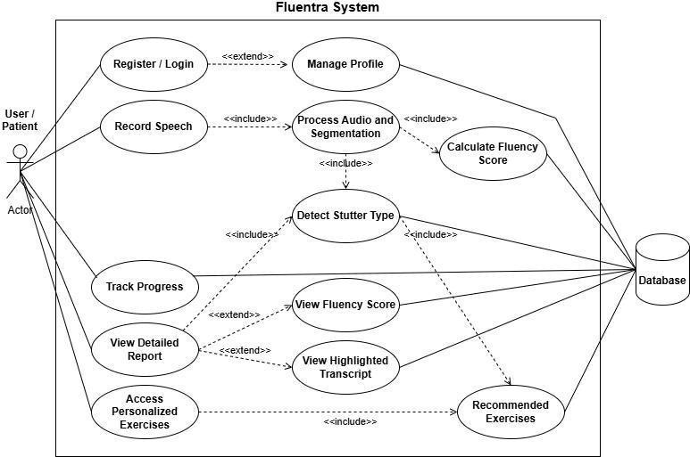

Chapter 4

System Design
Chapter 4: System Design
This chapter presents the complete design blueprint of the Fluentra system, detailing how the platform is structured and how its components interact to process speech and provide fluency analysis. It includes architectural design, showing the relationship between the presentation layer, AI processing modules, and database components. The chapter also describes the system’s internal logic through class diagrams, domain models, and ER diagrams, highlighting data flow and entity relationships. Additionally, sequence diagrams illustrate step-by-step processing of user audio from upload to analysis and reporting. Overall, this chapter provides the technical foundation needed for implementing a scalable, modular, and efficient speech-dysfluency detection system.

4.1. Architecture Diagram
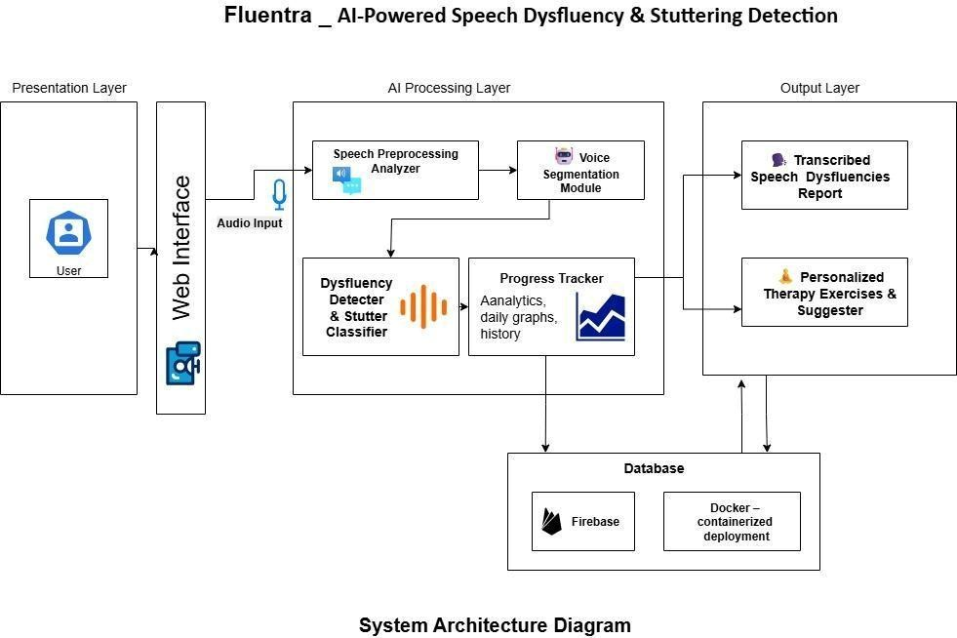

4.2. Use Case Diagram
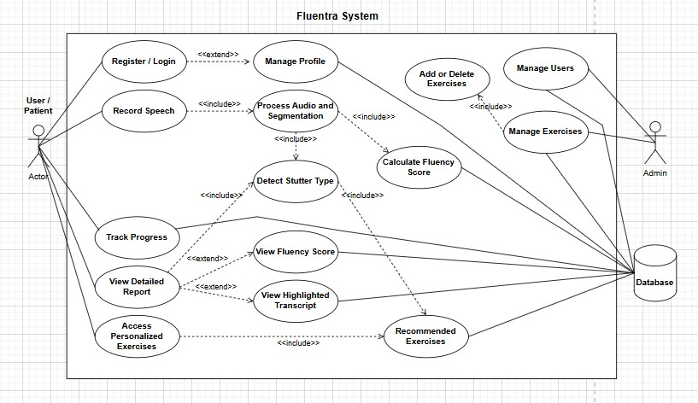

4.3. Domain Model

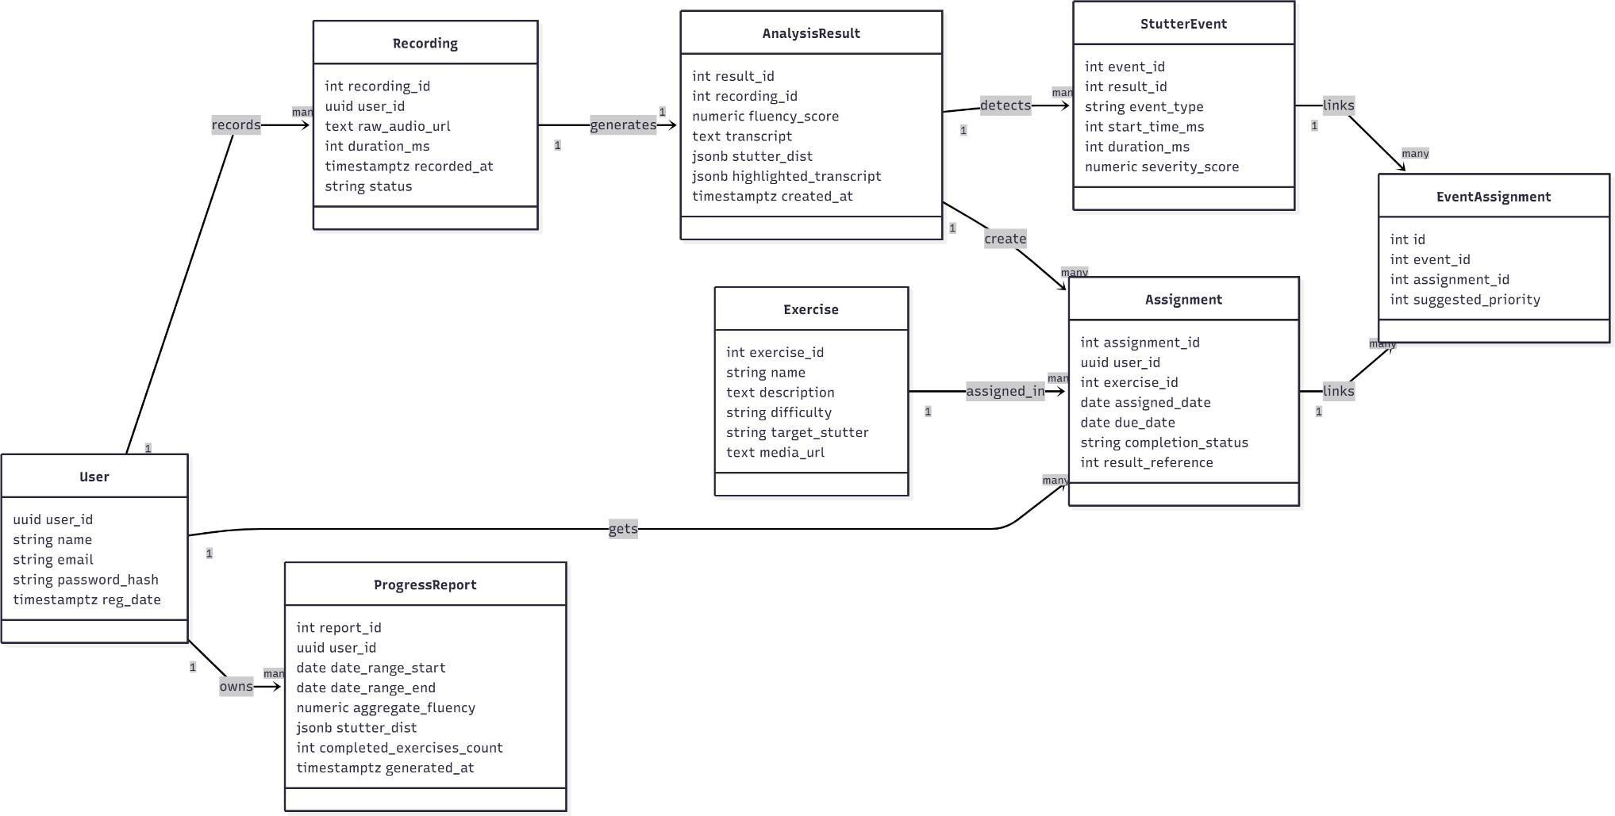

4.4. Entity Relationship Diagram with data dictionary

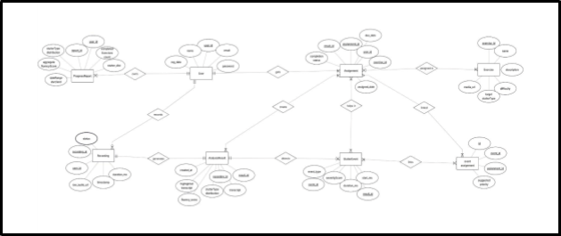

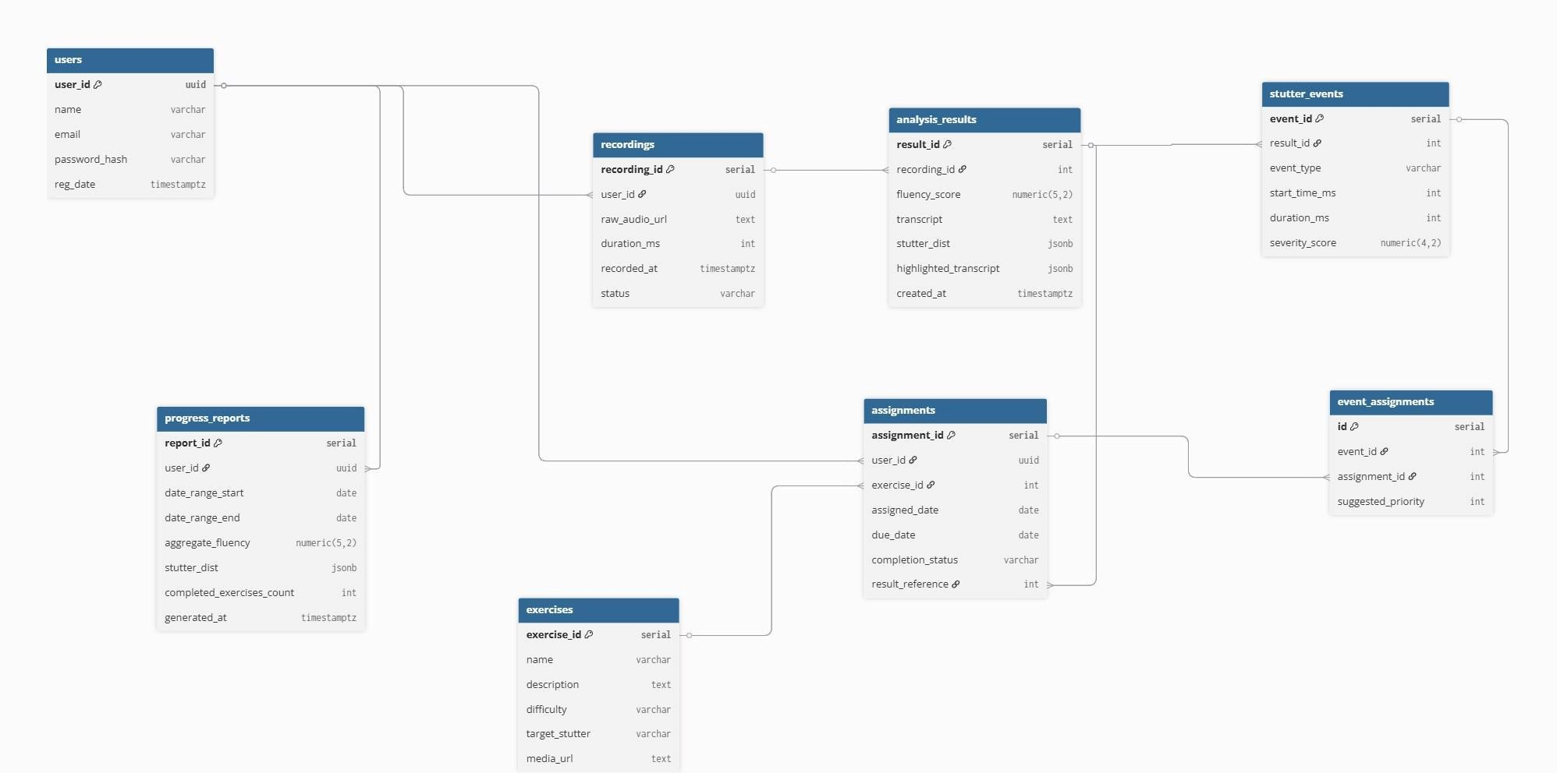

4.5. Class Diagram

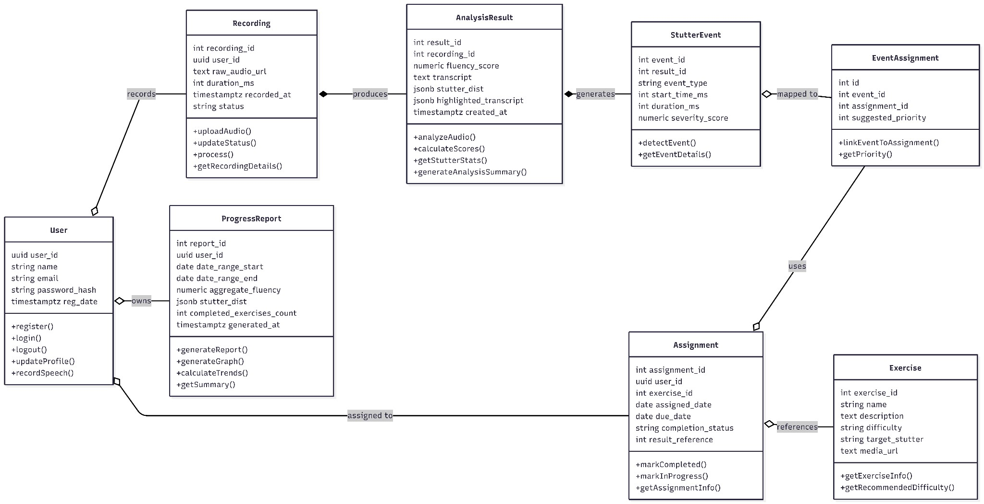

4.6. Sequence Diagram

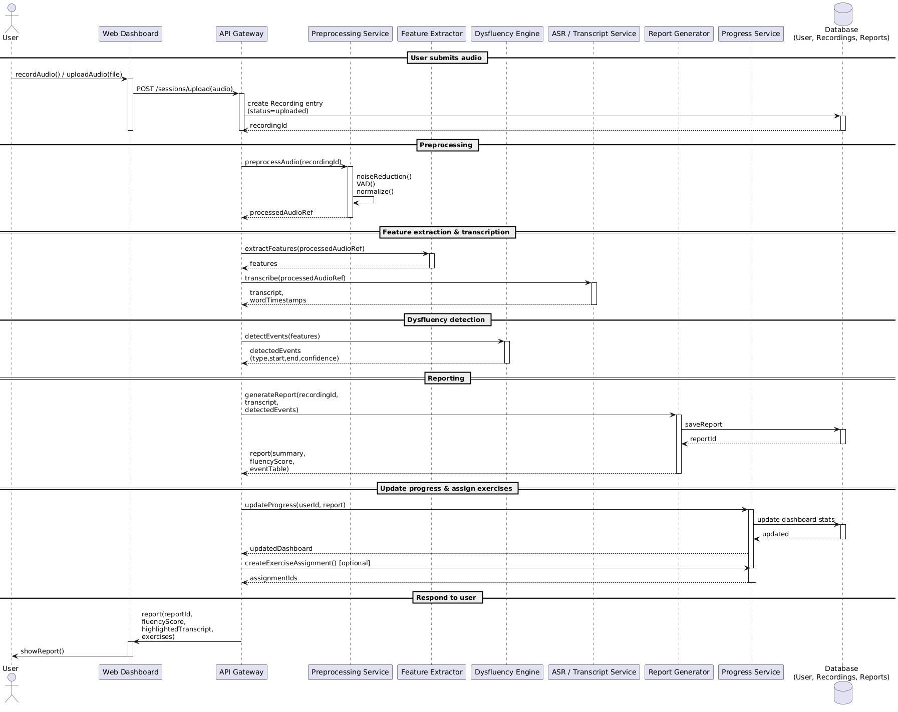

Chapter 5
Implementation

Implementation
The technical implementation of the AI-Powered Speech Dysfluency & Stuttering Detection system, FluEntra.
It describes how the conceptual design was transformed into a functional web-based AI system. The chapter outlines the system architecture, AI integration pipeline, tools and frameworks used, and engineering standards followed.

5.1 Important Flow Control / Pseudo Codes
The core functionality of FluEntra is governed by a structured backend pipeline that processes uploaded audio files. The system executes sequential, deterministic steps from user input to AI-based analysis. System Processing Pipeline
1. Audio Upload & Validation
User uploads an audio file; the backend validates file format, size, and sample rate.

2. Preprocessing
Audio is converted to mono @ 16 kHz and segmented into overlapping windows (1s window,
- 0.5s stride).
- Feature Extraction
Log-Mel spectrograms are generated using STFT for each segment.

5. Model Inference
Spectrogram batches are fed into the trained ensemble model (CNN + wav2vec 2.0).
Output: probabilities for (Normal, Block, Repetition, Prolongation, Interjection).

6. Post-Processing
Predictions are aggregated; high-confidence segments are merged into unified events with time stamps.
7. Report Generation
Fluency score, detected dysfluencies, statistics, and event timings are compiled.

8. Result Delivery
Results are returned to the frontend as structured JSON for visualization.
5.2 Components, Libraries, Web Services and Stubs
FluEntra uses a modular architecture separating frontend, backend, and AI layers.
System Components
- Frontend Client
React + TypeScript application for uploading audio, viewing results, and interacting with charts.
- Backend Server
Django REST Framework for handling requests, authentication, validation, and workflow orchestration.

● AI Inference Module
Python-based service loading PyTorch model, generating spectrograms, and performing batch inference.
● Database
PostgreSQL stores users, history, metadata, and reports.

Core Libraries and Frameworks
- Backend & AI: Django, DRF, PyTorch, Librosa, NumPy, SciPy
- Frontend: React.js, TypeScript, Axios, Chart.js
- Utilities: Celery, Redis, Docker
- Routing: React Router

Web Services & APIs
● REST API Endpoints o POST /api/analyze/ o GET /api/results/{job_id}/ o GET /api/history/

● Internal Stubs (Future Extensions)
FastAPI, TensorFlow Serving, or gRPC model-serving endpoints.
5.3 Deployment Environment
FluEntra is designed for cloud deployment using containerized services.
Development Environment
● Docker Compose setup including Django, PostgreSQL, Redis, Celery.

Production Environment (AWS/GCP)
- Compute: Dockerized Django app + Celery workers on ECS/GKE
- AI Model Hosting: GPU-enabled instances (AWS g4dn.xlarge)
- Storage: PostgreSQL RDS / Cloud SQL, Audio files on S3/GCS
- Frontend Delivery: React served via CDN (CloudFront) or static hosting
5.4 Tools and Techniques

Programming Languages
- Python
- JavaScript / TypeScript

Machine Learning Frameworks
- PyTorch
- TensorFlow (future model-serving integration)

Audio Processing Libraries
- Librosa
- NumPy
- SciPy

Backend Technologies
- Django
- Django REST Framework (DRF)
- Celery & Redis (asynchronous task execution)
- RESTful API architecture

Frontend Technologies
- React.js
- HTML, CSS, JavaScript, TypeScript
- Axios
- Chart.js

Database & Storage
- PostgreSQL
- Cloud Storage (AWS S3 / Google Cloud Storage)

Visualization & Reporting
- Chart.js
- (Plotly only if added later; currently not used)

5.5 Best Practices / Coding Standards
- Backend Standards: PEP 8, Black, flake8, Django project structure
- Frontend Standards: TypeScript strict mode, folder modularity
- Testing: pytest, Jest
- Security: JWT authentication, Django middleware, validation, ORM safety
- Type Safety: mypy (Python), TypeScript (frontend)

5.6. Version Control
- Repository Structure: Frontend + Backend under one GitHub repo with Docker Compose.
- Branching Strategy: main (production), develop (integration), feature branches.
- Collaboration Protocol: PRs, CI checks, code review approval, conventional commit messages.

